Curriculum Vitae (CV)

PERSONAL INFORMATION

Name: Dr. Wael Saadeldeen Mohamed
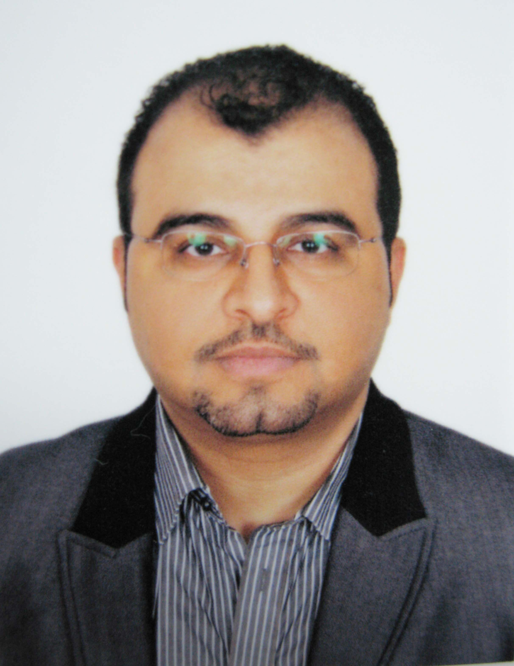

Nationality: EGYPTIAN
Birth Date & Place: 15/06/1970, Giza, Cairo, EGYPT
Marital Status: Married with four children
Languages: Fluent in Arabic and English, Good in French

Office: - 14 Mosaddak Street, Mohandseen, Cairo
- Gomhorryia St., Attebaa Tower, Assiut, EGYPT.
- Airport Road, Hurghada, Red Sea, EGYPT

Phone: +201005395056 / +201113302331

E-mail: waelsaadeldeen@gmail.com / waelsaadeldeen@esprs.com

Web Site: www.waelsaadeldeen.net

EDUCATION & QUALIFICATIONS

Bachelors (MB.Bch) degree from Faculty of Medicine Assiut University. Graduated in September 1994 with a very good degree.

Master (M.Sc.) degree in General surgery from Faculty of Medicine Assiut University. Graduated in April 1999 with a very good degree.

M.D. degree in Plastic Surgery, the Faculty of Medicine Assiut University 26/12/2004 with a thesis titled (Hair Restoration Surgery in Alopecia)

PROFESSIONAL EXPERIENCE

Dates: 22/5/2014 – present:

Ass Professor Plastic Suregry, Faculty of Medicine, Assiut University, EGYPT

Dates: 1/2/2011 – present

Consultant Plastic Surgery, Saudi Council for Health Specialties, Saudi Arabia

Dates: 1/8/2009 – 1/8/2013

Consultant of Plastic and Cosmetic Surgery, Al-Zallal Medical Center, Riyadh, Saudi Arabia

Dates: 1/8/2008 – present

Consultant of Cosmetic Surgery for EGYPT, WorthyMed World-wide Health Tourism, Argentina

Dates: 24/6/2007 – Present

Consultant of Plastic and Cosmetic Surgery, Nile Hospital, Hurghada, EGYPT

Dates: 3/12/2007 - Present

Consultant of Plastic Surgery, Faculty of Medicine, Assiut University, EGYPT

Dates: 28/11/2004 - Present
Assistant professor (Lecturer EG) of Plastic Surgery and Burns - Plastic Surgery department, Faculty of Medicine, Assiut University starting from 28/11/2004

Dates: 5/12/2004 – Present

Consultant of Plastic and Cosmetic Surgery, Red Sea Hospital, Hurghada, EGYPT

Dates: 18/4/2001 - 28/11/2004
Assistant Lecturer of Plastic Surgery and Burns: in Plastic Surgery Department, Faculty of Medicine, Assiut University.

Dates: 8/8/1999 - 17/4/2001

Specialist of Plastic Surgery and Burns: in Plastic Surgery Department, Assiut University Hospital.

Dates: 1/3/1996 - 7/8/1999

Resident of Plastic Surgery and Burns: in Plastic Surgery Department, Assiut University Hospital.

Dates: 1/3/1995 - 28/ 2/1996

House- officer: in Assiut University Hospital.

PLASTIC SURGERY EXPERIENCE

Aesthetic Surgery experience:
  - Closed and Open technique for Rhinoplasty
  - Revision Rhinoplasty
  - Non-surgical Rhinoplasty
  - Nasal Reconstruction
  - Innovated new technique for tip Rhinoplasty in Bulbous Noses
  - LASER Hi-Def Liposculpture of the face
  - LASER-Assisted HD Lipolysis and Tightening
  - LASER Brachioplasty (Arm Lipolysis and Tightening)
  - LASER – Assisted Facelift
  - LASER - Assisted Face lipolysis and Suction
  - LASER – Assisted Lower eyelid Blepharoplasty
  - Fractional CO2 LASER treatments for resurfacing, scars, and acne scars
  - Face lift and Forehead lift
  - Thread face lift ( Aptos, Silhouette Lift, Serdev Lift)
  - Facial Fat HD Bordering and Augmentation
  - PRP – Assisted Facial Fat Grafting
  - Micro-fat grafting the NJL and the Sub-orbital area.
  - Botox Nefertiti look
  - Soft tissue fillers for the Face, Breast, and Body
  - Botox injection
  - Facial Mesotherapy ( Mesosystem ) and Hair Mesotherapy
  - Blepharoplasty
  - Reduction and Augmentation Cheiloplasty
  - Breast Augmentation
  - Breast Reduction - superiomedial pedicle Technique
  - Suction –Assisted HD Abdominoplasty
  - Conventional Liposuction
  - Breast lift ; Mastopexy

  - Otoplasty
  - Medial thigh lift and lower body lift.
  - Brazilian Buttocks fat Grafts Augmentation and Lifting
  - HD Buttock Carving
  - French Legs LSAER-Ass Definition
  - Buttock Implants
  - LASER – Assisted Buttocks Carving
  - Injection Lipolysis ( Lipodissolve )
  - Augmentation of facial skeleton
  - Genioplasty
  - Brachioplasty
  - Autologous Micrograft hair transplantation surgery
  - Long-term post operative scar control regimen

Reconstructive Surgery and Burns:
- Post- traumatic, post- burn, and post Soft tissue deformities & contractures
- Excision and reconstruction of skin malignancies
- Congenital cleft lip and palate
- Congenital anomalies of the hand
- Congenital anomalies of the auricle
- Haemangiomas, Congenital moles and giant naevi ( surgical )
- Hypospadius , Epispadius, and its surgical complications
- Hair restoration in post- traumatic post- infective, and post- burn cases
- Congenital microtia by either prosthesis or cartilage graft
- Dynamic reconstruction of the Facial palsy
- Dermabrasion for the post acne scars and for hyper pigmentation
- Abdominal hernias with or without Hernioplasty
- Bed sores
- Foot & Leg ulcers
- Reconstruction of old scars
- Nipple and areola reconstruction
- Marjoline’s ulcers (P.B. Malignant Ulcer)
- Management of all types and degrees of Burns
- Management of soft tissue loss in trauma cases

PROFESSIONAL MEDICAL MEMBERSHIPS

- Member of the Egyptian Society of Plastic and Reconstructive Surgery (ESPRS)
- Member of the French Society of Aesthetic Surgery (SFCE)
- Member of the European Society of Aesthetic Surgeons (ESAS)
- Member of the International Society of Plastic, Reconstructive, and Aesthetic Surgery (IPRAS)
- Member of the World Society Interdisciplinary Anti-Aging Medicine
- Member of the Saudi Scientific Association for Plastic surgery and Burns
- Member of the Egyptian Medical Syndicate
- Member of the Mediterranean Council for Burns and Fire disasters (MBC)
- Member of the International Society for Burn Injuries (ISBI)
- Member of Operation Smile International

CONFERENCES & SEMINARS

- Attendance of the Annual International Congress of the French Society of Aesthetic surgery in collaboration with the American Society of Cosmetic Surgery.
- Attendance of the annual meeting of the Egyptian Society of Plastic and Reconstructive Surgeons (ESPRS)
- Attendance of the Middle East International Congress of Plastic Surgery, Dubai-UAE.
- Attendance of the International Meeting of the Saudi Medical Association For Plastic Surgery and Burns
- Attendance of the Annual congress of the European Society of Hair Restoration Surgery
- Attendance of Q-Med workshops; Riyadh (KSA), Beirut (Lebanon)
- Attendance of the annual congress of Assiut Faculty of Medicine
- Attendance of the summer meeting of the (ESPRS)
- Attendance of the Assiut Instructional course for Burns

AWARDS

  - Awarded the King Abdulaziz University Shield for presenting New Technique in Rhinoplasty in the Internatinal meeting of the SSAPSB, Jeddah 2010-07-18
  - Awarded the Best Paper Prize in the International 39th Meeting of the ESPRS February 2009 for presenting ( BUILDING-UP TOTTALY NEW TIP IN PATIENTS WITH BULBOUS NOSES )
  - Awarded the Medal of the French Society of Aesthetic Surgery for presenting ( Reduction Rhinoplasty ) in the international meeting of the SFCE, Paris 2006

PUBLICATIONS

- Genetic Studies on the Inheritance of Lip Prints in-Cleft Lip and Palate; Egypt, J. Plast. Reconstr. Surg., Vol. 29, No. 1, January: 9-12, 2005
- One Stage Reconstruction of The Post-Human Bite Lost Helical Rim; Med. J. Cairo Univ., Vol. 77, No. 3, 6: 633-642, 2009.
- Cheiloplasty of the Post Burn Deformed Lips; Annals of Burns and Fire Disasters - vol. XXII - n. 2 - June 2009.
- Pinhole Vagina Following Mismanaged Vaginal Delivery; JOURNAL OF GYNECOLOGIC SURGERY;
Volume 26, Number 4, 2010
- OBJECTIVE VERSUS SUBJECTIVE ASSESSMENT FOR RHINOPLASTY; Egypt, J. Plast. Reconstr. Surg., Vol. 37, No. 1, January: 73-79, 2013
- BUILDING UP A TOTALLY NEW TIP IN PATIENTS WITH SEVERE BULBOUS NOSES; Egypt, J. Plast. Reconstr. Surg., Vol. 38, No. 1, January, 2014
- Nd: YAG Laser-Assisted Brachioplasty, No More Scars; Egypt, J. Plast. Reconstr. Surg., Vol. 38, No. 1, January, 2014
- Laser-Assisted Hi-Def Lipsculpture of the Jawline and Mento-Cervical Areas; Egypt, J. Plast. Reconstr. Surg., Vol. 38, No. 1, January, 2014
- AUGMENTATION OF ATROPHIC DEPRSSED SCARS UTILIZING THE DE-EPITHELIALIZED SCAR TISSUE ITSELF; Med. J. Cairo Univ., Med. J. Cairo Univ., Vol. 82, 2014

MEDICAL THESIS SUPERVISION

- Recent Advances in Septo-Rhinoplasty; Thesis submitted for partial fulfillment of the Master Degree in General Surgery, March 2006-March 2009, Dr Tarek Mohamed Raef: Resident of Plastic Surgery, Assiut University Hospital, EGYPT.
- Fournier’s Gangrene; Thesis submitted for partial fulfillment of the Master Degree in General Surgery, March 2007-March 2010, Dr Awney M. Showiqat: Resident Of Plastic Surgery, Assiut University Hospital, EGYPT.
- Comparative study between open and endoscopic techniques in Plastic Surgery; Thesis submitted for partial fulfillment of the M.D. Degree in Plastic Surgery, September 2008-Now, Dr Mahmoud Sayed AbdulHameed: Specialist Of Plastic Surgery, Assiut University Hospital, EGYPT.
- Objective versus subjective evaluation of Rhinoplasty; Thesis submitted for partial fulfillment of the M.D. Degree in Plastic Surgery, September 2008-Now, Dr Mohamed M.A. El-Otiefy: Specialist Of Plastic Surgery, Assiut University Hospital, EGYPT.

MEDICAL EDUCATION TRAINING

Dates: 18/4/2001 - Present
Clinical education for the medical students at the clinical 6th grade of General and Plastic surgery study in the Faculty of Medicine –Plastic Surgery Department, Assiut University, Assiut, EGYPT.

REFERENCES

1- Prof. Mahmoud Eloteify, (Chairperson of Plastic Surgery in Upper Egypt)
Phone No. : 0020123971608, e-mail : oteify@gmail.com

2- Prof. Foad Ghareeb, (General Secretary of the ESPRS, Professor of Plastic Surgery- Menofeyia University)
Phone No. : 0020122126011, e-mail : fghareeb@yahoo.com

3- Prof. Mustafa Elsonbaty, (Professor and Head of Plastic Surgery Deprtment. Assiut University)
Phone No. : 0020103142066, e-mail : mustafa_elsonbaty@hotmail.com

4- Prof. Mohamed kadry, (Honory President of the Egyptian Society of Plastic and Reconstructive Surgeons, Professor of Plastic Surgery- Cairo University)
Phone No. : 0020123181446, e-mail : mo402@yahoo.com

5- Prof. Assem H. Kamel, (Professor of Plastic Surgery, Assiut University)
Phone No. : 0020105319242, e-mail : assemkamel888@yahoo.com

6- General Professor Atef Emam, (Head of Plastic Surgery, Armed Forces Hospitals, EGYPT)
Phone No. : 0020106045650, e-mail : Atef.emam@hotmail.com

7- Dr Antony Erian, (President of the European Society of Aesthetic Surgery- ESAS, UK)
Phone No. : 00447768821210, e-mail : erian@erian.demon.co.uk

